## **ADVANCED DATABASE MANAGEMENT**

Your Name: STEPHEN OMONDI  
Your SUID: 946934043  
Your Email: SOOMONDI@SYR.EDU  
Date Due: Wednesday, October 09, 2019  
Homework #: LABWORK 1

2019-1002 IST 679

# Part 1: The ITELL vLab

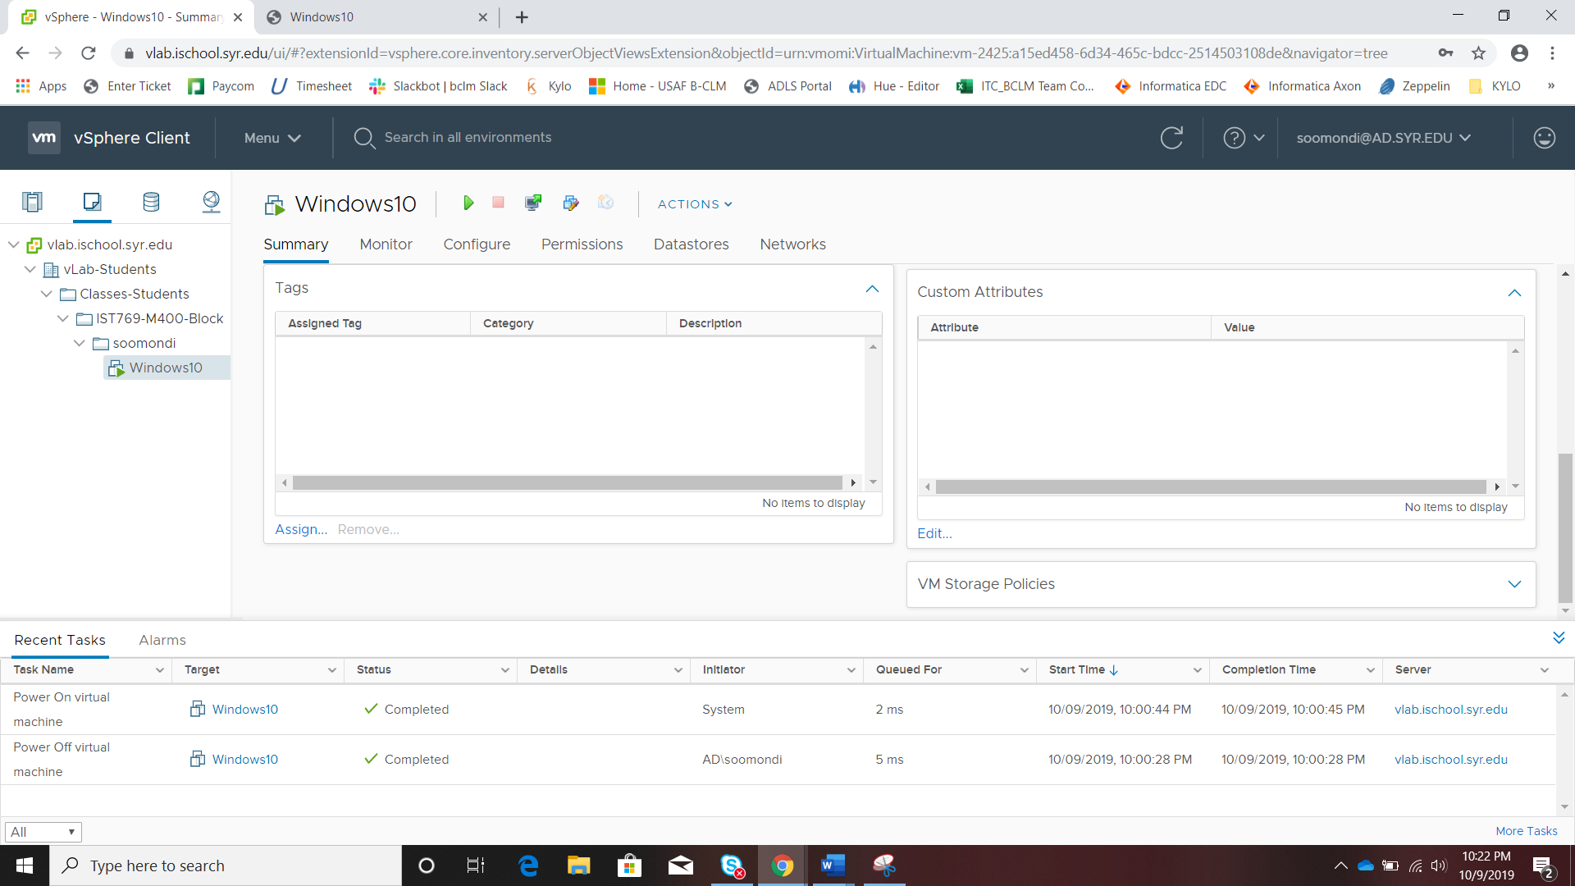

# Part 2: Getting the Lab Containers and Supporting Files

## Cloning the Labs and Datasets

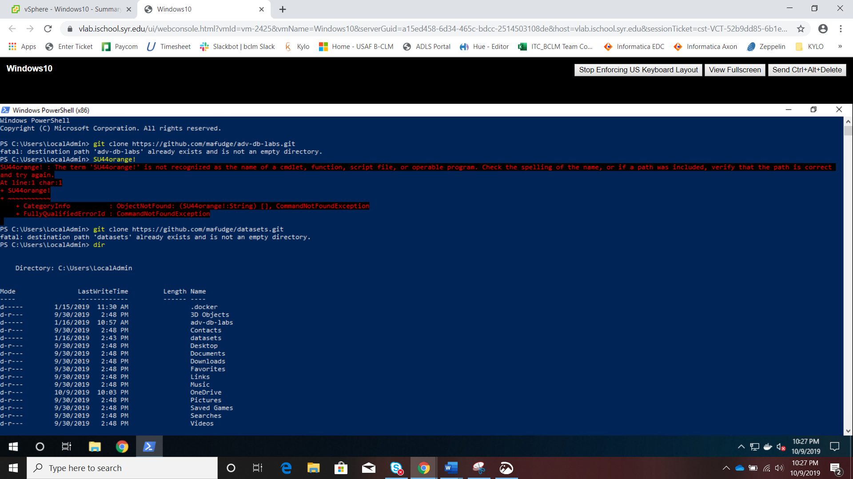

## Accessing the Repository folder

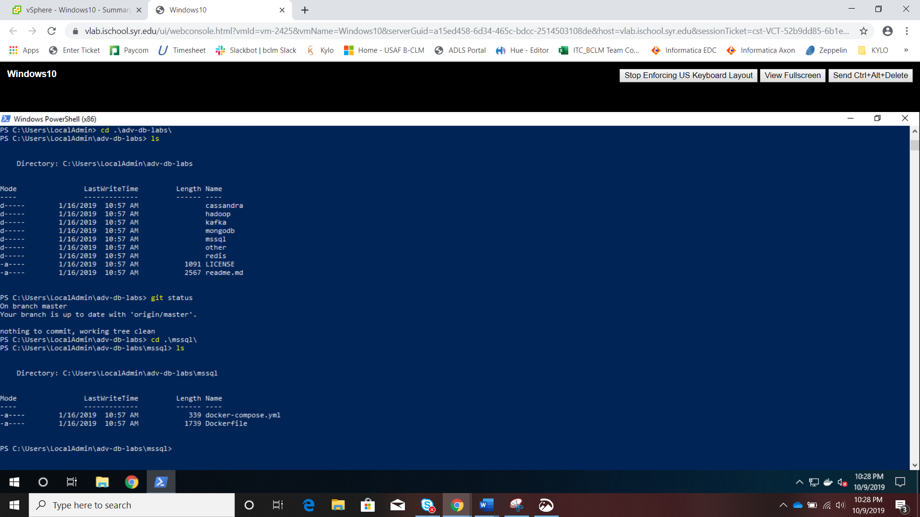

# Part 3: Common Docker Commands

## Setup

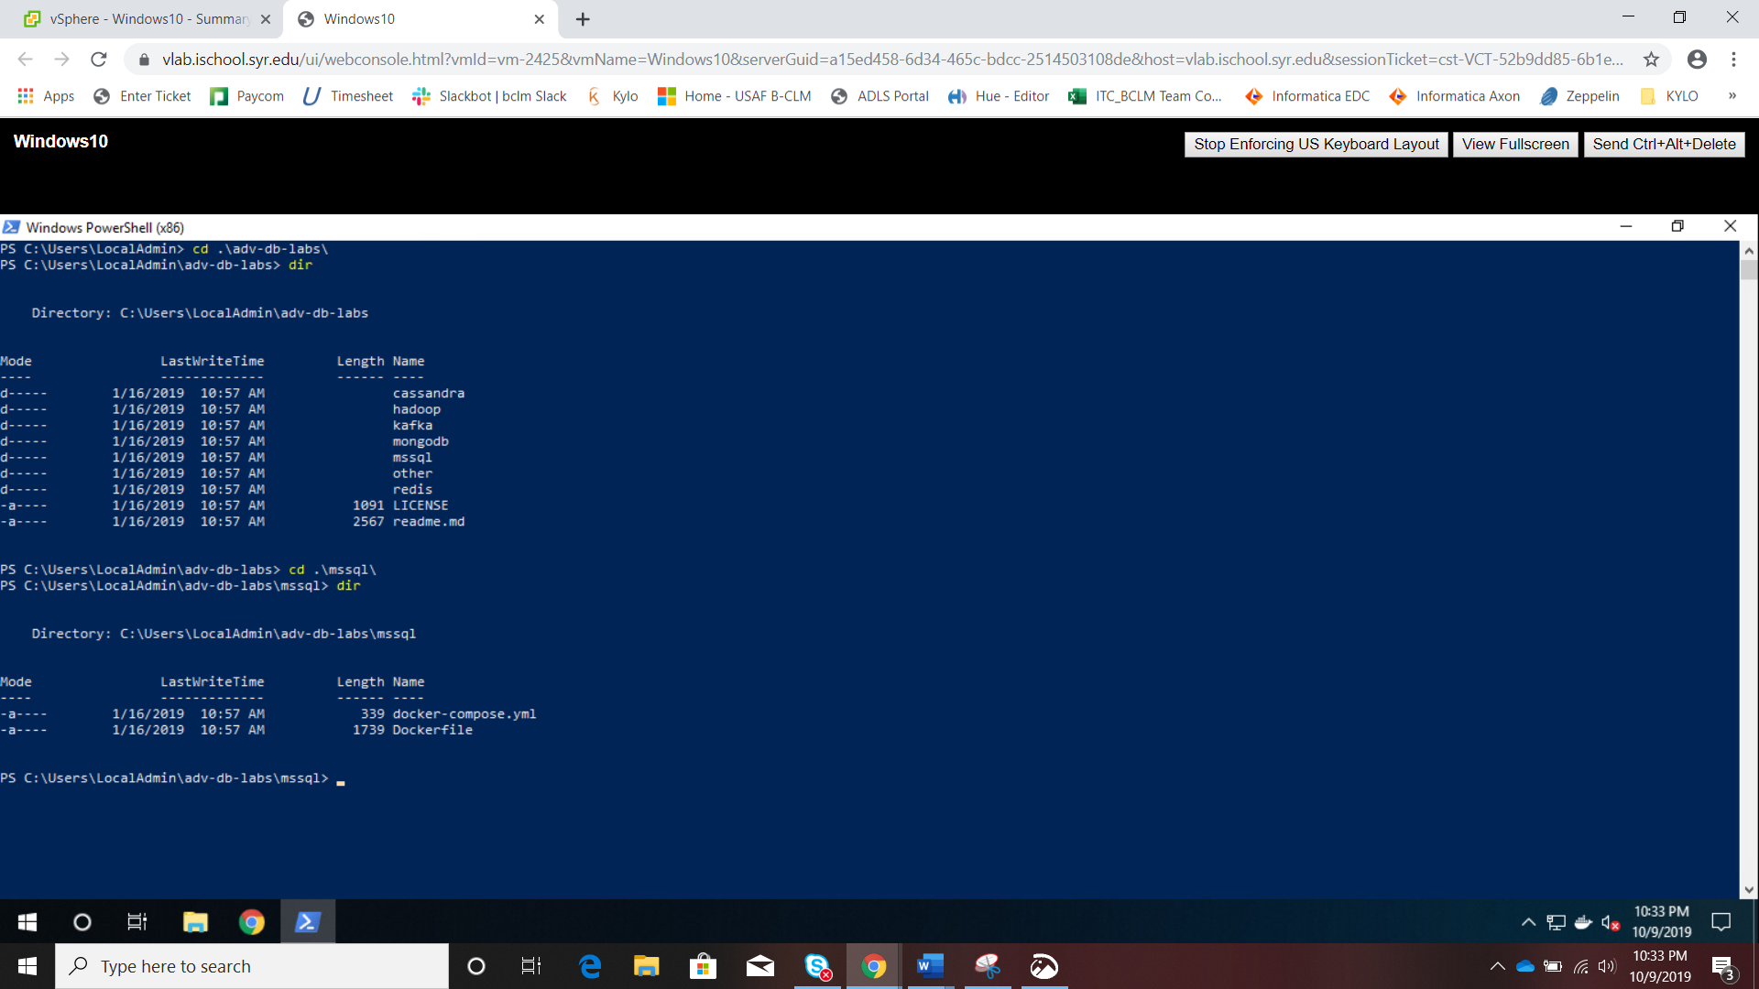

## Walk-Through the Docker Commands

## **Starting a service and checking which services are running:**

## 

## **Creating Databases**

## 

## **Checking that fudgmart_v3 has tables and that tables have data in them:**

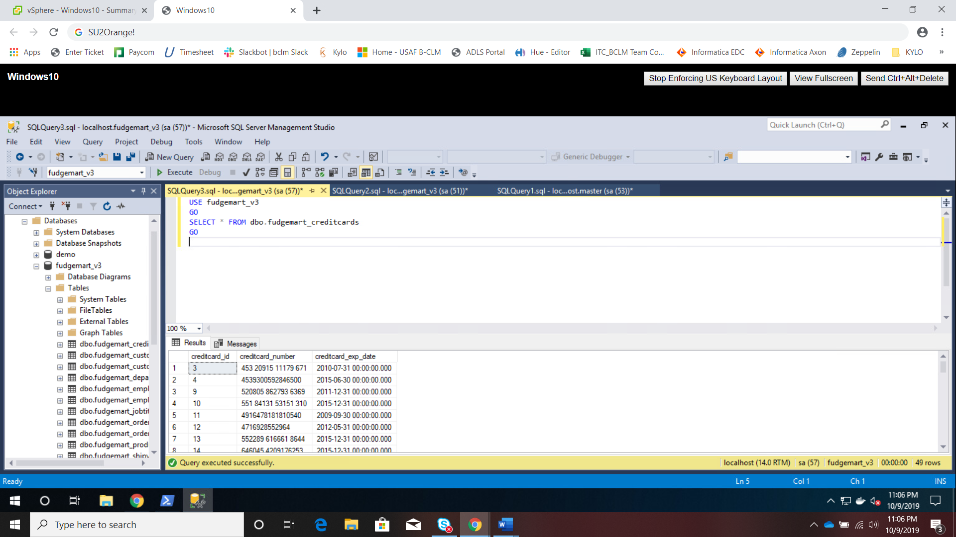

## **Terminating Docker services**

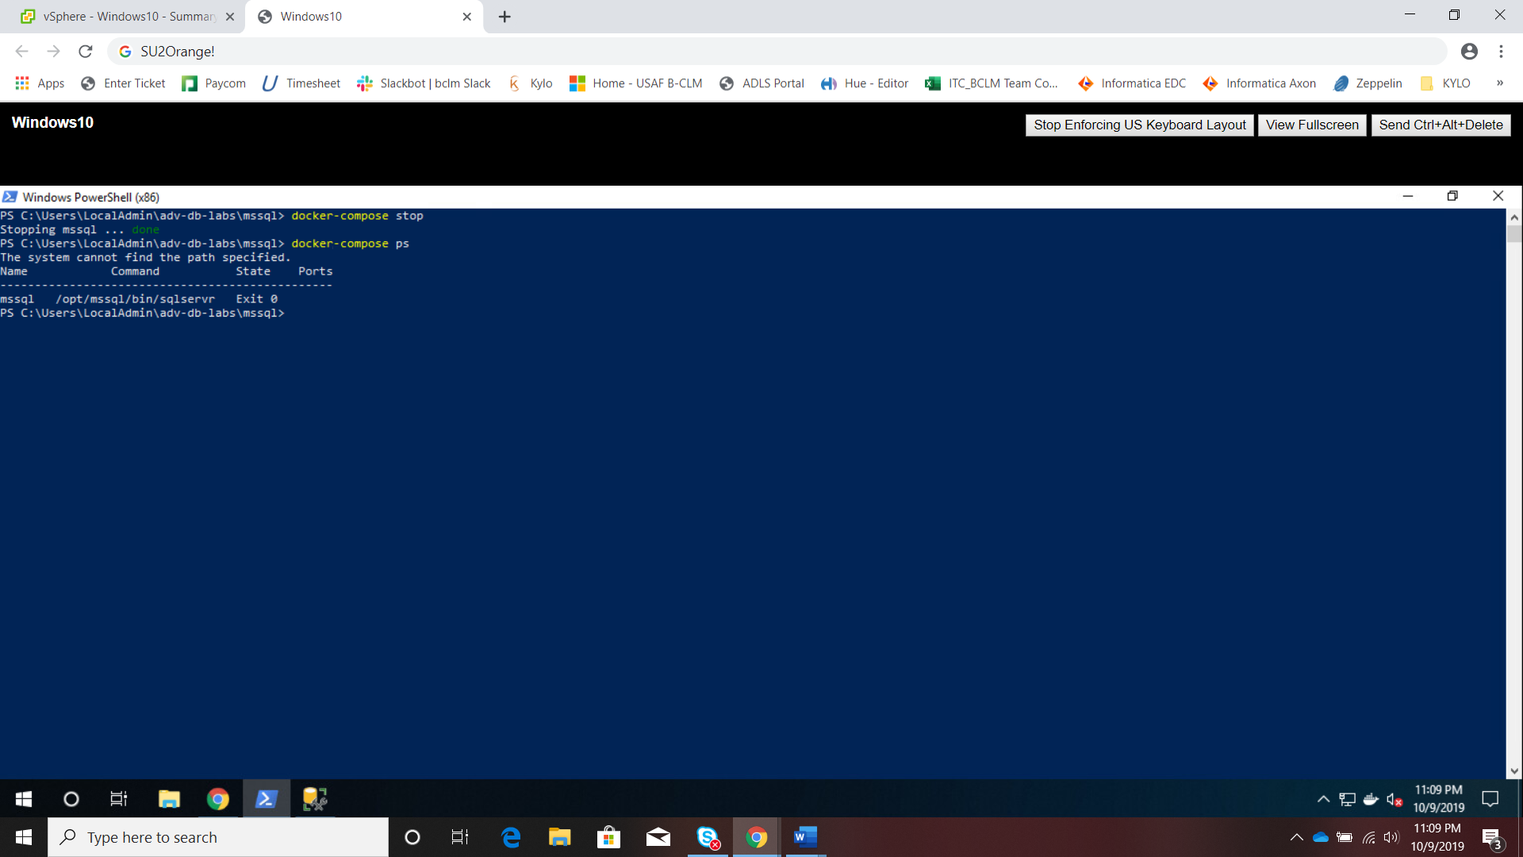

# Exercises

1. **What would be the command to bring up the redis environment? How is the command different from the mssql environment? How is it the same?**

cd .\redis\

docker-compose up -d

docker-compose ps

docker-compose exec redis redis-cli

It is different from the mssql environment because these commands are called inside the *redis* directory – not *mssql* directory. Also, they differ in how the client is called, redis client is called with *docker-compose exec redis redis-cli*. However, the same command structure is used in both cases – once inside the specific folder/directory to start the environments.

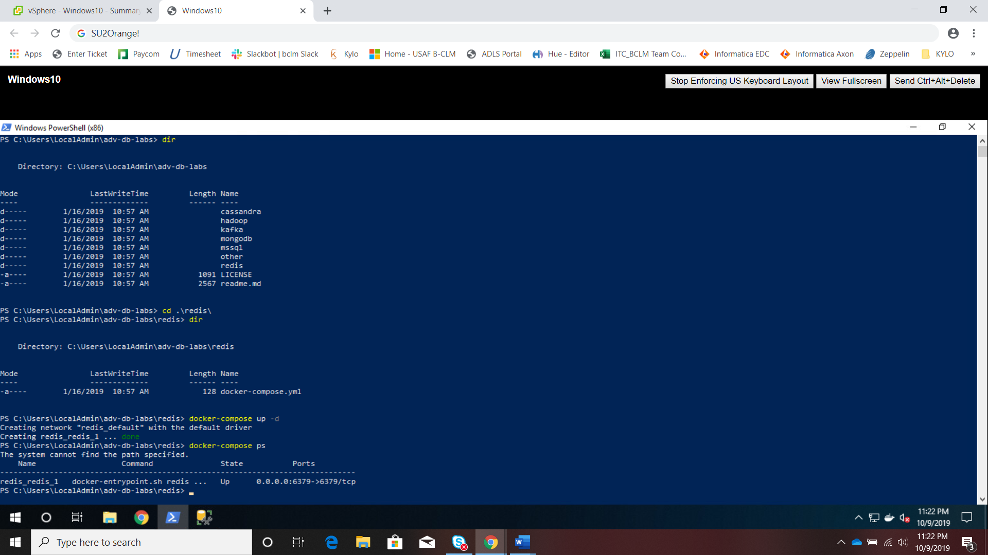

1. **Where is the specific configuration information about each environment stored?**

It is stored in the *docker-compose.yml* file found in each directory/environment.

1. **Explain the difference between stopping an environment and bringing it down. Elaborate with use-cases for each.**

Stopping the environment terminates the current service instance that are running but does not lose the objects created thus far. Bringing the environment down removes all objects created during the session of the running environment – it resets the whole environment as if no objects were ever created.

1. **What happens when you bring up an environment that is already up?**

You receive a notification that the environment is already up-to-date:

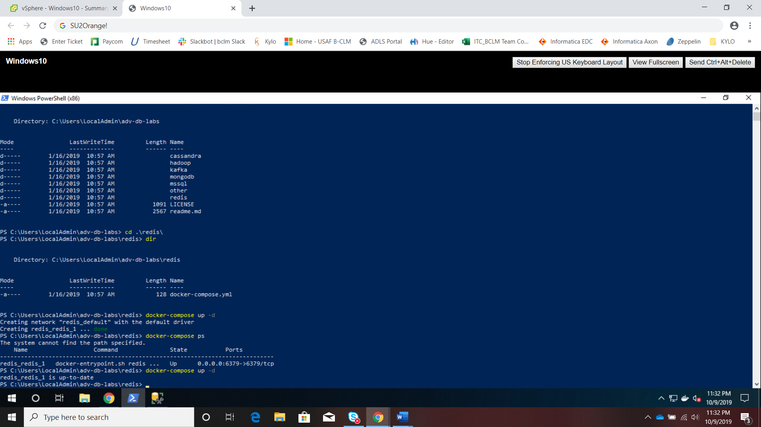

1. **What was the most difficult aspect of this lab? What changes could be made to make it less difficult?**

Accessing the vlab was a little cumbersome, but I think this should get better with practice.